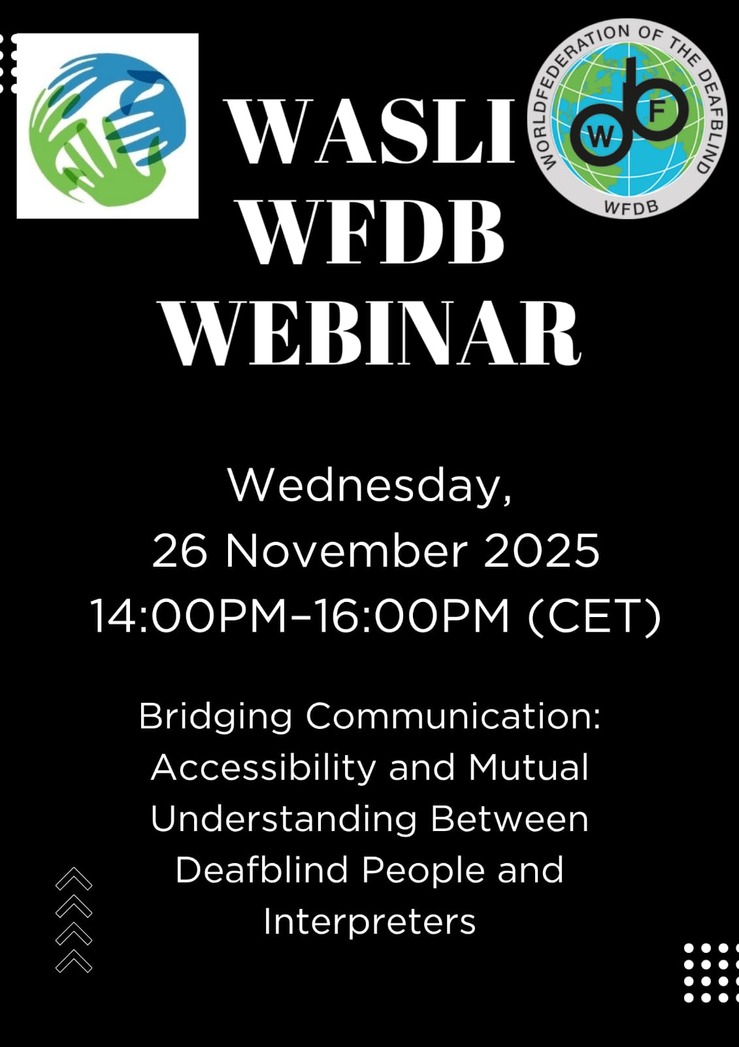

Image description: This image is a promotional poster for a webinar jointly organized by WASLI and WFDB.
The poster has a black background with a clean and formal design. At the top, the logos of both organizations are displayed—WASLI on the left and WFDB on the right. In the center, large white text reads: “WASLI WFDB WEBINAR.”
Below, the event details are provided:
Date: Wednesday, 26 November 2025
Time: 14:00 PM – 16:00 PM (CET)
The theme of the webinar is: “Bridging Communication: Accessibility and Mutual Understanding Between Deafblind People and Interpreters.”
At the bottom, subtle graphic elements such as arrows and dotted patterns add a modern visual touch. The overall design conveys a professional, international event focused on communication, accessibility, and collaboration.
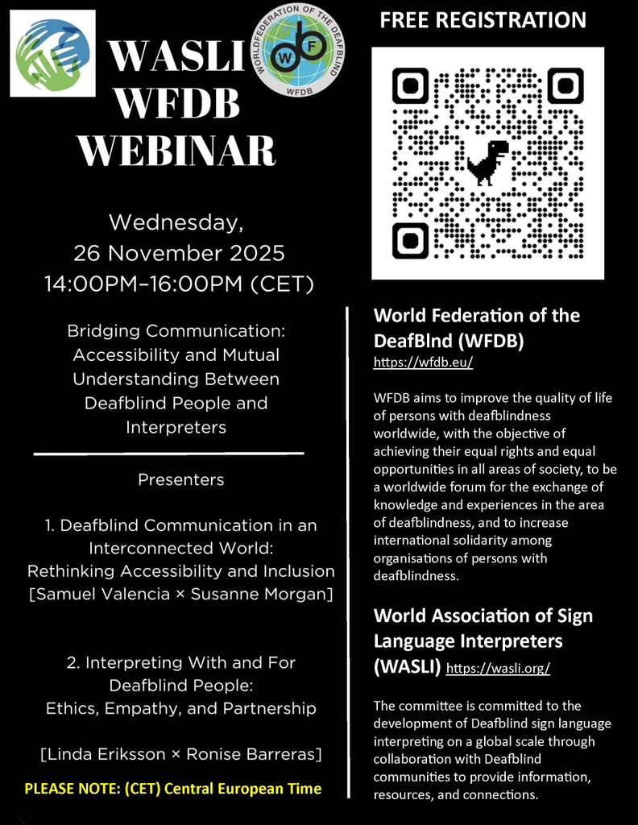

Image description: This image is a detailed promotional poster for a webinar organized by WASLI and WFDB. The poster has a black background with a structured layout divided into two main sections:
Left Section (Event Information)
At the top, the WASLI and WFDB logos are displayed. Below them, the title reads: “WASLI WFDB WEBINAR.”

The event details are listed:
Date: Wednesday, 26 November 2025
Time: 14:00 PM – 16:00 PM (CET)
The theme of the webinar is: “Bridging Communication: Accessibility and Mutual Understanding Between Deafblind People and Interpreters.”
Further down, the Presenters are introduced: Deafblind Communication in an Interconnected World: Rethinking Accessibility and Inclusion
– Samuel Valencia & Susanne Morgan Interpreting With and For Deafblind People: Ethics, Empathy, and Partnership– Linda Eriksson & Ronise Barreras
At the bottom, there is a note indicating that CET refers to Central European Time. Right Section (Registration & Organization Info) At the top, there is a “FREE REGISTRATION” label with a large QR code for easy sign-up.
Below the QR code, there are descriptions of both organizations:
WFDB: Focuses on improving the quality of life and rights of persons with Deafblindness worldwide. WASLI: Supports the development of sign language interpreting globally, especially in collaboration with Deafblind communities.

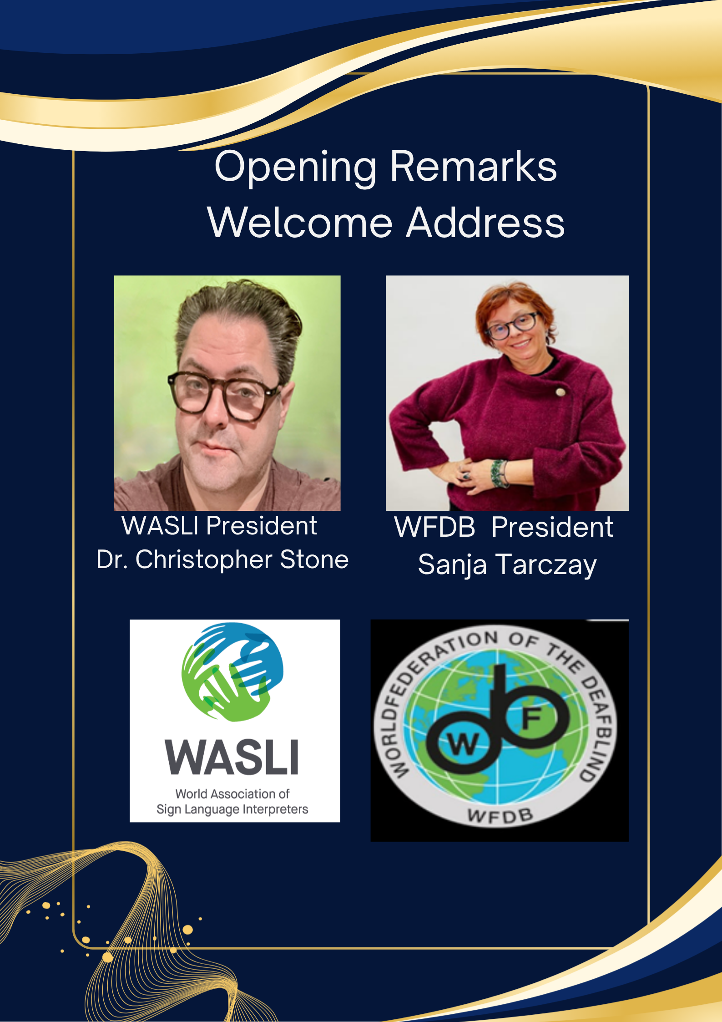
Image description: This image is a formal event slide titled “Opening Remarks Welcome Address.”
It features two keynote speakers:
Dr. Christopher Stone, identified as the President of WASLI. His portrait appears on the left, showing a man wearing glasses against a soft green background.
Sanja Tarczay, identified as the President of WFDB. Her portrait appears on the right, showing a woman smiling and wearing glasses and a red sweater.
Below the photos are the official logos of both organizations:
The WASLI logo, featuring stylized hands forming a globe.
The WFDB logo, showing a globe with the letters “WF” integrated into a symbol. The slide has a dark blue background with elegant gold decorative waves and borders, giving it a professional and ceremonial appearance suitable for an international conference or webinar.

Introduction about WASLI WFDB Webinar:
Lydia Koh (Vice President, WASLI):
Good evening, good morning, or good afternoon, everyone.
It is a pleasure to have all of you here with us today. We originally planned to meet on Zoom, but due to the high number of participants who wanted to watch this webinar, we have now transitioned to YouTube. We are excited for today's event, which focuses on the experiences of Deafblind individuals and interpreters working in this field.
The World Association of Sign Language Interpreters (WASLI) and the World Federation of the Deafblind (WFTDB) have worked together over the years, and this is our very first co-hosted webinar on Zoom and YouTube. This inaugural event is very exciting.
Who am I, you may ask? My name is Lydia Koh. I am the Vice President of the World Association of Sign Language Interpreters (WASLI). I'm from South Korea, and I am delighted that all of you are here with us for this webinar. We anticipate a great presentation and a great discussion.
The languages for this webinar will be spoken English and International Sign. You will have seen the planned keynote presentations from the material provided.
First up, I would like to introduce Christopher Stone, the President of WASLI. He will say a few words.

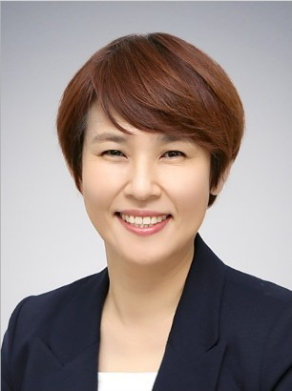 | 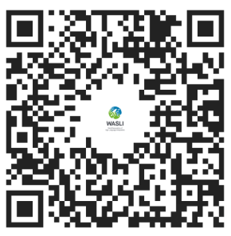

Christopher Stone (President, WASLI)
Greetings. This is my sign name, and my name is Christopher Stone. I am the President of the World Association of Sign Language Interpreters (WASLI), and I'm delighted that we are co-hosting this event with the World Federation of the Deafblind. The two organizations have been working together for some years. We have engaged in partnerships over the years—some on-and-off—and we've had a signed agreement. It is very exciting that this is the first time we are coming together to co-host this webinar.
We had numerous discussions about what the topics should be, and we agreed that this topic—access for hearing, Deaf, and Deafblind interpreters—is great because it has a wide reach. I hope that you learn something from tonight that you can take into your work. Thank you.
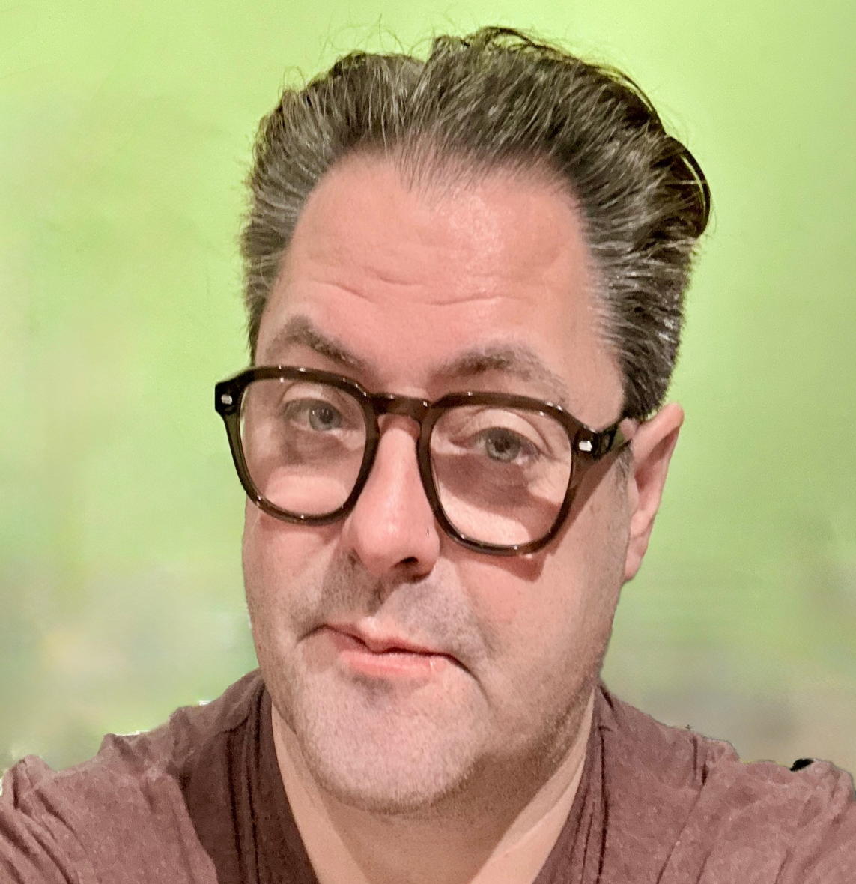 | 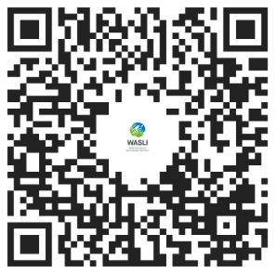
Sanja Tarczay (President, WFDB)
Thank you all. Good morning everyone, good evening or good afternoon, depending on where you are around the globe. I am very happy to be here. My name is Sanja Tarczay as you’ve already heard. This is my sign name (shows sign) and I am a Deafblind woman. I am also the President of the World Federation of the Deafblind (WFDB), this is the sign for WFDB (shows sign), and the First Vice President of the International Disability Alliance (IDA). I am really happy today, and I want to thank the WASLI team for their coordination and mutual organization of this event. I am sorry for any inconveniences that might have happened before. This is our first online webinar, and sometimes there are technical problems or other issues, but I know that since this is the first time, we will definitely do better next time. Thank you for joining. There are three important things that I would like to talk about in my introduction.
1. About WFDB
First is about my organization, the World Federation of the Deafblind (WFDB). You may have heard that we are the true and global voice of the Deafblind community around the world. We have regional representatives from all continents: Europe, Asia, Africa, Latin America, and North America, which makes us a big family, with now more 75 members as well. Our association also consists of Deafblind individuals who support our work. Our goals are advocacy and achieving Deafblind persons' rights. Before, Deafblind persons were left far behind, and now in many countries, we still do not have Deafblindness recognized as a distinct disability, which means that the Deafblind persons are not supported adequately. One of the problems was also terminology.
For example, we were considered "deaf and blind," "deaf/blind," "deaf-blind," "blind and hard of hearing," or "visually impaired and hard of hearing," and many other combinations. This really caused trouble in inserting Deafblindness into policies. In cooperation with Deafblind International (DbI), we have managed to officially agree on the term "Deafblindness," and we are now all under that umbrella.
2. The Deafblind Diversity
When people think about Deafblind persons, they have to realize that we are very diverse. We are a community that consists of many different combinations of impairments: deaf with visual impairment, or blind with hearing impairments of different levels, or fully Deafblind. There are many different combinations, but what we have in common is that we all have a hearing and visual impairment to a certain level. So, regardless of our diversity and diverse needs, we are all Deafblind persons. This last year, we had a big achievement: the recognition of the International Day of Deafblindness within the UN. That is one step further that we have made globally, and now we are refocusing on services for Deafblind persons.
3. Services/Terminology
That is the following point that I want to talk about, and we started working on it with WASLI. I think that is a very important topic because this topic is also very problematic. Some of the problems are related to terminology as well, which causes a lot of problems. "Deafblind interpreter" is one of the phrases that people use.
Then there is "Deafblind assistance," some say "guide-interpreter," some say "interpreter-guide," and many other options. We have different terminology which causes problems because many countries have diverse support provided for Deafblind persons, and in many countries, Deafblind interpreters are put in the category of assistance, which means lesser salary. Some countries do have it sorted out much better, but still, the majority do not because we have different terms that we use for Deafblind support services. So, we have now started to work proactively in resolving that, so that we can all acquire an equal level of high-quality interpreting services. Also, I think it's important to emphasize that Deafblind interpreters are not only interpreters for persons who use sign language. There are interpreters for diverse Deafblind persons: for persons who use loud speech, for persons who use braille, or writing on the palm, or different ways of communication. It is important to know that regardless of our differences and different ways of communication, we must achieve equal rights and have the high-quality interpreting services that we need individually. That's very important for us. I don't know if you've seen my sign for 'Deafblindness'. Before, many signs were wrongly used; for example, the sign for 'deaf-mute' covering your mouth, which caused offense. That is why we have this different sign for 'Deafblind' as well, in order to respect certain parameters. You will hear more about Deafblind interpreting ethics and professionalism from our two Deafblind representatives, Linda and Samuel. And we have two experienced Deafblind interpreters who are about to inform you regarding the topics that we're covering today. I hope that you will enjoy and that you will learn something new today. I want to express my gratitude to WASLI for organizing and coordinating this webinar. Thank you and your representatives, and all the interpreters that are involved in this webinar with a special thanks to Lydia Koh. I hope that you will find this webinar productive. Much love from me.
Thank you

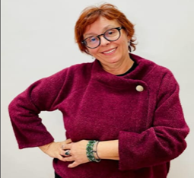 | 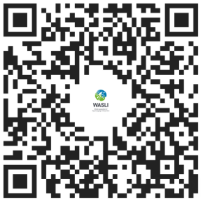

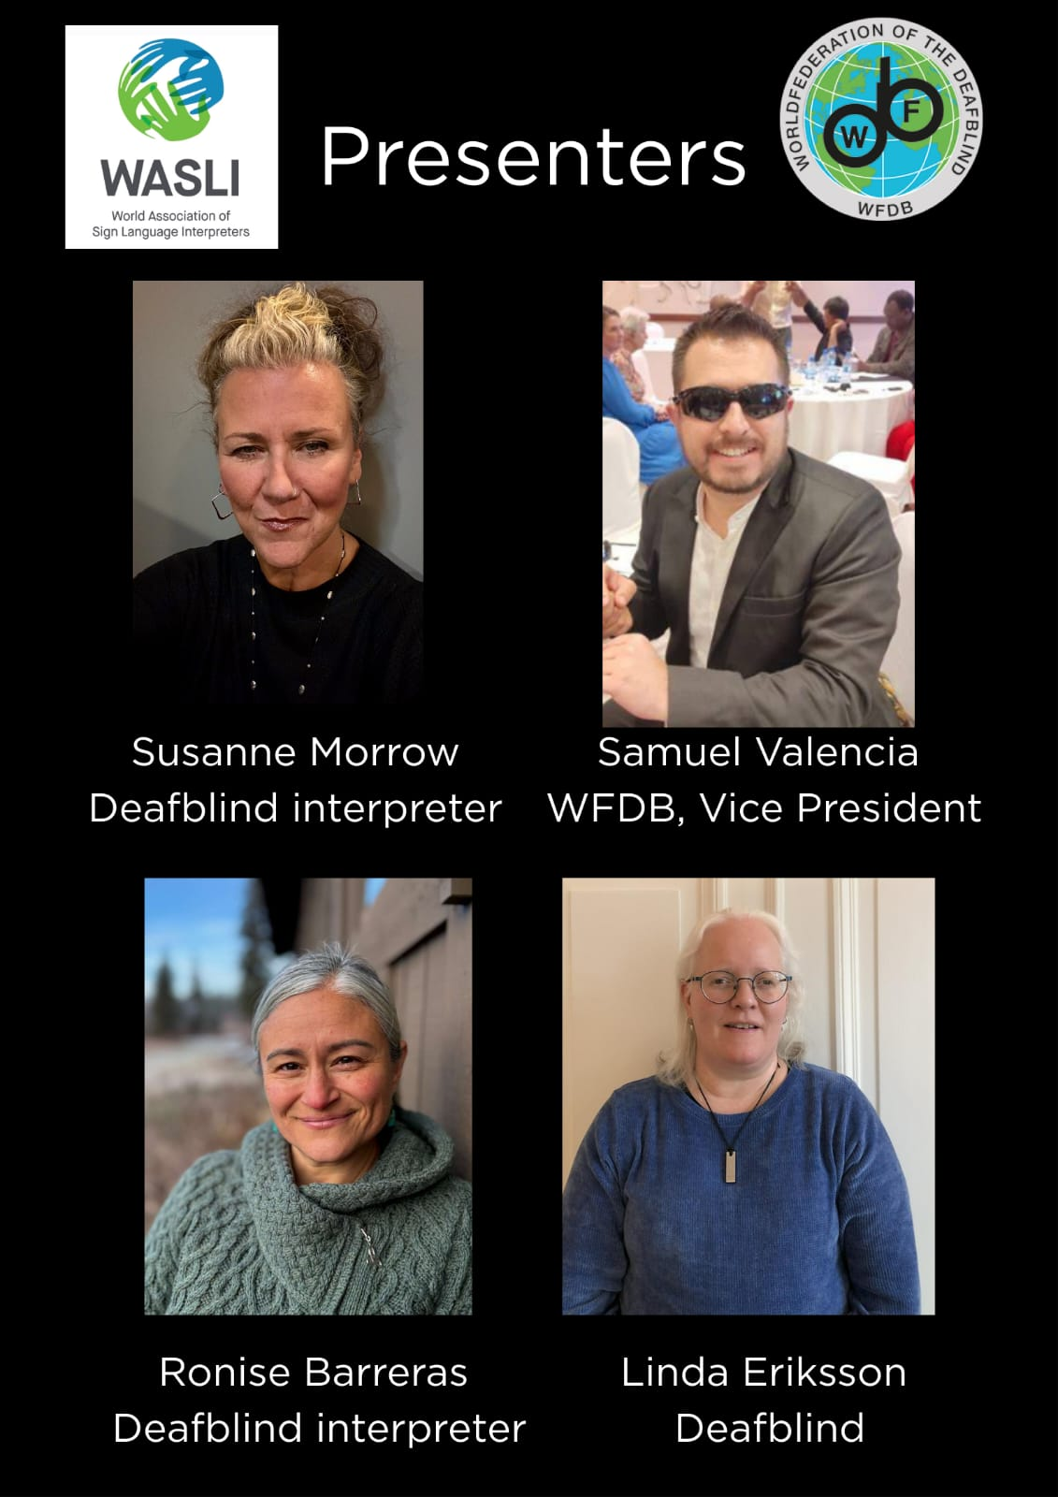
Image description: This image is a “Presenters” slide for a webinar organized by WASLI and WFDB.
The slide has a black background with the logos of both organizations at the top. Below, four presenters are introduced with their photos and roles:
Susanne Morrow – A Deafblind interpreter, shown in a portrait with her hair tied up. Samuel Valencia – Vice President of WFDB, pictured wearing sunglasses and a suit in a social setting. Ronise Barreras – A Deafblind interpreter, shown outdoors wearing a green sweater. Linda Eriksson – Identified as Deafblind, shown wearing glasses and a blue top.
Each presenter is positioned in a grid layout with their name and role written beneath their photo. The overall design is simple and professional, clearly highlighting the speakers participating in the webinar.
Samuel Valencia (Vice President, WFDB)
Hello everyone my name is Samuel Valencia. I am a Deafblind person. I'm totally Deafblind. I am a psychologist and also have a master's in administration. I am Vice President of the World Federation of the Deafblind. I'm very happy for the words that Sanja addressed to everyone, where she explains the importance of understanding the diversity of our disability. And by my side, I have my Deafblind interpreter or guide interpreter. She is Lucero and all the time I am working around Deafblindness and I’ve worked in my country about the training, formalization, and recognization of the Deafblind interpreters.
One of the essential points that I want to address to understand persons with Deafblindness, is understanding that sometimes people use terminology that is not the most accurate to represent us. Persons with Deafblindness, it is a population with persons with disability. And since we are a population with a disability, that means that we understand it becauce of the barriers that represent the society against us.
In the book; The Deafblindness: A Multi-Disciplinary Analysis, chapter three, Danielle Alvarez wrote, it tells us to understand Deafblindness not as a community but as a population that is different from other communities because we don't have a lot of similar elements or factors similar to other communities. That it's important to know that Deafblindness is recognized as a unique disability because we combine different impairments, visual and auditory impairments. That's when the barriers become communication, access to information, and mobility. And always, when we have persons with Deafblindness or we identify ourselves, what we have in common are the barriers, even though we sometimes see it in different ways. So, it is really important to understand that when we define ourselves as a population with a disability,
we always talk about the three barriers in general: communication, mobility, and information, that are always lingering around us or always interfer in the access to our rights, location, the right to participation, the right to work.
To eliminate those barriers, we have different ways to do it. When we talk about disability, we talk about barriers, we also talk about how we eliminate those barriers. And one of the most important aspects in the elimination of those barriers is having Deafblind interpreters and guide interpreters. This is one of the most important means that we have as Deafblindness population, to eliminate those barriers.
As well, Sanja was saying, the term or the concept of 'guide interpreter' or 'Deafblind interpreter' varies. So as it is said in different ways, it has been conceptualized in different ways, and sometimes, it is that those ways have been wrong. For example, it is really common to understand or to think that the guide interpreter is a sign language interpreter, as if all their performance is just around sign language. But the real function and the real objectives of the guide interpreter is different.
People with Deafblindness we have different communication systems. And people that work as Deafblindness interpreters have to try to adjust to the different barriers that this specific persons might have. That's because of the diversity that we have in our communication systems. That's why it is really important that when we're talking about guide interpreters as an eliminator of barriers for people with Deafblindness, it's not only the Deafblindness or the barriers itself, but it's sometimes the compound of these barriers.
For example, the relationship with our context. Sometimes it is not only about the communication or the linguistic aspect. Sometimes it's what is happening around us, that’s the information that we are not receiving. But for example, giving mobility for people with Deafblindness. That’s also part of the development of the behaviour of the persons with Deafblindness in a physical space and to their daily life. Not everything is around or revolves around sign language.
So that's why it's really important that we find these essential functions that eliminate the barriers for the Deafblind persons. In Colombia, for example, we have identified that in practice, in reality, the guide interpreter has five general competencies or five general functions. We say that these are five functions in certain way, this is something we conclude after a study that we did with the Deafblind population, an also with Deafblind interpreters and there associations and other factors.
And between these five functions, we have: Mobility and orientation.
Giving and transmitting information from different systems that may be auditory around us. Assistance of what we need.

Assistance with technology and the information devices that we use as Deafblind persons. Assistance in different aspects.
What happens for example, we, as Deafblind people, sometimes, we have barriers which depends on the specific characteristics for each individual. So, these Deafblind guides or Deafblind interpreters, they adjust to our individual needs. That's why Deafblind interpreters needs to be trained to do that work. That is why the training of these guide interpreters needs to be led by Deafblind people and its needs to be through a formal education.
It is not correct to think that Deafblind interpreters or sign language interpreters are the ones that have to actually train Deafblind interpreters because it is not the same, they have different needs. So sometimes they need more specific information for more specific needs.
So, we are understanding that the Deafblind interpreter is a very important element to eliminate barriers, but there comes another term that is really important, which is accessibility. Sometimes we have difference or sometimes we have misconceptions about the Deafblind interpreters that talks about accessibility. But accessibility have complex terms and it's joined with a very important concept which is reasonable adjustment. With reasonable adjustment, it is really important to understand that there are adjustments that are individual, that are personalized to each and every individual. Every person with Deafblindness has unique and different needs.
For example, Sanja has her own needs, and also her service and participation are different, I also have different needs too. So, each person with this disability or with Deafblindness has different needs. That is where the Deafblind interpreter comes into play because their service has to be adjusted individually to every person that they are working with. Accessibility is not personalized. Accessibility is general. When we understand these terms with accessibility, accessibility is a different context. That's why we say that we can complement those terms, but they have different areas of works. For example, accessibility is for everyone.
Another thing that is important for us to understand is the support that we have, That the Deafblind interpreters have a support in their lives, so, we need to understand the diversity. The role of the Deafblind interpreters just need to be adequate to the diversity of the population. Some people are just Deaf and then they lose their sight, their needs are totally different, and sometimes, when we have these types of populations that have been accustomed only to sign language, they transition from being a Deaf person to becoming Deafblind, or for them to understand their new disability, it's really difficult for them.
They struggle with the difference between a sign language interpreter and a Deafblind interpreter because this person is understanding their new compound disability between the population of Deaf people or Deafblind people. So, we need to understand that we have diversity. Some people go to rehabilitation access, and they have different therapies, and they can understand different communication systems. So, they need different support.
Deafblind interpreters have very specific functions that are different from sign language interpreters. They are totally different roles. Precisely, within the federation, we're trying to create a new committee of Deafblind interpreters so we can adjust all these elements and all these lines of work of Deafblind interpreters, so we can have better access and better services. We understand that there are some people who really want to support and want to understand, but it is also a right for us to understand the Deafblind interpreters as a reasonable adjustment, as people who give a service. So, it is really important to understand the specificity of this roles and that we can continue with this so we can try to find these rights.
Right now, WASLI, we have the World Federation of the Deaf and we have a lot of Deafblind interpreters that are being trained. We hope that we can continue giving visibility to this role. We can continue training them, and we can try to find them. It has also have been joined with all the associations of Deafblind persons. They can give us our best service in the way that we actually need.
My job within this work is not only to working, but I've been working a lot within this field, and sometimes we have all the challenges, sometimes it is not about only the Deafblind interpreters but also having different demands and different needs. But it's also important for all the work that we've been doing about the formalization of the Deafblind interpreters and the work of the Deafblind interpreters needs to be also be done with the Deafblind people which cannot be separated. Why? Because we are the main focus, and Deafblind interpreters have to actually meet the needs of these population.

In the case of Deafblind interpreters, I'm going to use my example in particular, because, I also need my interpreters with me, because I need them around. And they need to give me mobility. I need this direct physical contact for me to understand and to have full access. So, I understand this is a very important topic, and we need to talk more about it. We have a short time right. I hope we have more opportunities to continue talking about this and we can continue, as I said, to give visibility to this work. That's why we are really happy that WASLI and the work that we are doing is stabilizing the work that Deafblind interpreters are making right now. People with Deafblindness we need to understand the associations and the federation with Deafblindness, and the world federation of the deaf and the different regions have a really big task to work toward the recognition of the work of the Deafblind interpreter and that also gives us access to participation that talks about training. Deafblind interpreters find our needs, try to actually respond to our identity or our characteristics as a population. So, we have different lines. It is not only one specific way that we can work. We have to try to work with this diversity. So, I am really open to continuing working in this field, and I'm really open to give training. Thank you very much for allowing me to give this information.

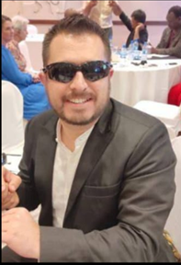 | 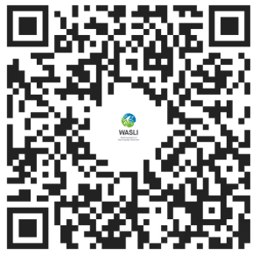

Susanne Morrow
Susanne: Good morning. Good morning here from the United States. New York city. Very excited to be here with you sharing exciting information. Let me pull up the power point. This can also be shared at a later time. Let me first describe. I am a hearing, white, woman. With long curly hair sitting in an office.
I am very thrilled to see many of my friends from around the globe today. It’s lovely to reconnect. It’s an honor to be here to talk about this important topic as we all learn and grow together. So, my name is Susanne. My sign name is an “S” using ASL off the cheek. But what is important to also say is my “touch sign” or my ProTactactile sign is a swipe down the arm and a tap and why that is important is because it is particularly related to this topic today.
My focus is talking about understanding the power of touch as it relates to our role as an interpreter. I think it’s so important that both Samuel and Sonya have already talked so clearly about the diversity within the community, but also the quite diverse range of terms that are used for essentially the same role of an interpreter. Whether that is a guide interpreter, a Deafblind interpreter, an interpreter guide. I think we’ve already established in this short time that we are all functioning in the same ways, with the same beliefs as the Deaf Blind individual as the leader. That we must learn together. But within that diversity, that foundation across all experiences is this power of touch. So, I want to spend just a few moments talking about that.
From my perspective and our very short time together today I would like to talk about three aspects that truly impact the work we do as interpreters. One relates to the Science of touch. The second, the lived experience from Deafblind adults. Then the third, how we, as interpreters can support the autonomy or independence of Deafblind individuals. So, about the Science of Touch. I think this is something that most likely, interpreters are not thinking about when they are doing their work. We may not be trained in the area of cognition and how the brain functions because we are really focusing on making communication happen. Providing the best access as possible. But I think if we take a look at what is actually happening in the experience of the body, it might raise a little bit of awareness of what our role is and how we are using our hands in the communication with individuals. Because all humans experience the sense of touch. Its physiologic. In very rare cases there may be considered touch blindless or may be no means of interpreting touch because of some sort of damage perhaps to the central nervous system or some sort of rare condition. But for the most part, every individual experiences touch. Which starts at the very beginning of the entry into the world. And what science tells us, is that there are two pathways in the brain that processes touch as information is experienced from the outside world. And those two pathways in the brain cannot be separated.
The first is discriminative touch. That is what tells us the facts about what we are feeling. The vibration of a feeling. The pressure of something. The location on your body or near you. The textures of the things that we are feeling. On the screen you can see there is a picture of someone kneading some dough. And with that, how much tactile information is being experienced through discriminative touch. And so how do we experience this touch? Well, its within everything. The clothing that we wear, the smoothness of the outside of an apple, the chill of a bowl of ice cream, etc. but what is very critical when we think of discriminative touch is the hands and the interaction of the interpreter. So, what we must remember then, and think very clearly, is that touch is not void of emotions. Touch in the discriminative sense does not stand alone. The second aspect of touch then is the emotional side of touch. How we truly experience the feelings associated to the things we are touching. That’s where interpersonal connection comes in between the communication partners. And if those two pathways cannot be separated, we as interpreters need to very much think how we are using our sense of touch and how it’s being received.
Because what Deafblind people tell us, is that over the course of their lives, they may have experienced very very significant means of negative touch. And in my role as interpreter with Deafblind adults and young adults I have been learning through these experiences. But also, in my day job I am the Director of a federal grant for New York state for children who are Deafblind. So, it is absolutely critical that we listen and learn from these experiences of Deafblind adults. To learn from those mistakes of how touch has been experienced in negative ways and making sure we are changing those approaches for young children so that they can grow in ways that will develop trust, develop rapport, and avoid this concept that is often talked about regarding children who are Deafblind as being tactile defensive. Meaning resistant to touch. So, we must think about our role as communication partners. Weather it is an interpreter or even a family member or other educators working with children. Where did that tactile defensiveness or resistance to touch come from? And most likely, it came from us. Not being aware of the most appropriate and most respectful way to use touch.
On the screen is a picture of several people communicating with each other. Two individuals are Deafblind sitting face-to-face with three other communication partners sitting around. You can see here that there is a variety of engagement with the use of touch. So, what’s important is that we are listening directly and learning directly to people who are Deafblind to tell us what is working what is successful strategies and what are those that are not.
And the biggest question I think is. Are we asking? We have to continue to ask. So luckily for us, as things have evolved and changed over time. We are learning directly from Deafblind adults who have developed a language called ProTactile language. You may have heard it called PT or PTL. This is a language that is developed by and growing and eveloving directly from Deafblind indivduals. The quote on the screen says “ProTacticle Language allows Deafblind people to give, receive and exchange information through a tactile channel, rather than relying on auditory or visual channels to access information and language.” And what is so powerful about ProTactile and its philosophies and principals is that it truly takes touch as the primary means of access. This is a big shift for weather you are a Deaf interpreter or hearing interpreter. But as sighted people, people who rely on vision allows us to shift the way in which we are thinking about providing access. So how does this relate to autonomy? Since touch is so powerful, it can either suppress or diminish or put down someone’s independence or autonomy or it can truly lift someone up. So as interpreters, how are we suppressing Deafblind people’s autonomy? Most likely it’s through a concept thorough Vidism. Having sighted privilege. Using an individual’s sight. If someone is a sighted individual it is natural that we learn and have access to information. About 90% of that comes through our vision. So, if we are completely reliant on vison and not thinking about touch. Incidentally or by accident we may suppress a Deafblind person’s autonomy. The second concept also within ProTactile language relates to a term Distantism. Meaning we often live in a culture where touch is taboo, not allowed, not welcomed. So, if we are operating in a way where we are avoiding touch. Touching to things in the environment, and to people. That is another way in which we are suppressing a Deafblind person’s autonomy. So, we need to be thinking about, as interpreters, are we relying on these access channels rather as opposed to thinking from the means of touch.
So then how do we switch that and support Deafblind individuals. It’s already been mentioned this morning; ask the person’s preference. Since every individual may have a different approach and a different experience related to touch and how they experience the world. And their own individual experience may be changing and evolving as they learn different access points. Ask the questions before making assumptions. As an interpreter, I think we have to constantly be mindful of those other channels meaning vison and hearing. So be mindful of the incidental auditory and visual information that as an interpreter you have access to, and think about how we can raise that bar to an equivalent level through the means of touch for a Deafblind person. And of course we have to be discoverers. We have to be searching out that information. And again, asking the person preference about what sort of information about the environment is essential for that individual. And understanding that depending on the environment, those choses may change.
On this screen there are three people seated together. There is a hearing interpreter on the left, a Deaf interpreter on the right, and a Deafblind individual in the middle. My good friend, Ryan. You can see there are different points of touch happening and what that shows is that there are ProTactile principals in practice. One interpreter is maintaining a very close connection. Touching knees, having the hand on the leg of the individual while the other communication partner is providing access through touch. So, I would strongly encourage interpreters to learn about what are those ProTactile principals. And first and foremost and the most primary, is this concept called “co presence” and Samuel already said. The concept of with, not for. With meaning co, simultaneous. Doing something alongside the Deaf individual at the same exact time means we will be able to access information in a more equivalent means. Thinking about the idea of sighted privilege again. This is a perfect example. There are three individuals here communicating together. There is a lot happening in the visual environment. It’s all in choice making and providing that information to the Deafblind person.
And I’d like to leave you with one simple example but a simple example that comes with so much power. The elevator button example. And what that means is let’s say you were walking towards an elevator with a Deafblind person. You are the guide relying on your vison to provide guiding, providing access to communication. As you approach the elevator. Who pushes the button? It might be as simple as that. And interpreters incidentally make these choices all throughout their work. We move in a fast-paced world of a lot of auditory information. A lot of visual information but in the simple act of approaching an elevator, as you walk with an individual, who reaches out to press the button? How does the individual know they’ve arrived even at the elevator? How often have as an interpreter have you had a Deafblind individual hand on your hand or on your arm but you’ve incidentally reached out with the opposite hand to press the button. That simple example actually takes away the autonomy of the Deafblind person. So those simple acts that we do build on top of each other. And they can be very successful strategies or they can be catastrophic. So, I would challenge you to think the next time you are providing guiding, providing information, who is reaching out? And what hand are you using? And are you doing that with the Deafblind individual? We can approach the elevator together and press the button. A simple example, but I am hoping a very powerful one.
Thank you for your time today. I wish we could spend more of these hours together and more on a regular basis. I look forward to future opporutnities to be in person to be able to touch and have real communication again soon.

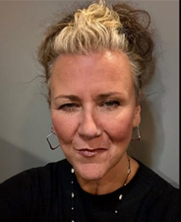 | 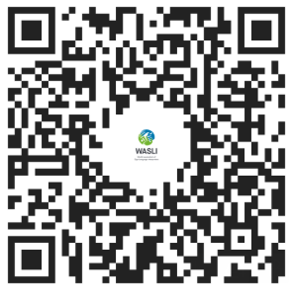

Linda Eriksson
(Pedagogue, Swedish Association for Deafblind)

Hello. this is Linda speaking. Linda Eriksson. So I'm Linda and my name sign is Linda. I also have a personal haptic, a social haptic name sign with the capital L and my name sign connected under the capital L. Linda.
I'm from Sweden and today I'm representing the association, the Swedish Association for Deafblind. I also work as a pedagogue at the National Resource Center for Deaf Blindness. Previously, I've been working as a teacher at a sign language interpreter and Deafblind interpreter training. And during that time I wrote a book with a colleague and that book is called a handbook for Deafblind interpreting.
I have both slides and script. And I'm most I freely would like to share all that material with you. What I would like to raise as an aspect and issues issue today is the aspect on deaf blind interpretation and the role of deaf blind interpreters. Firstly I would like to address a warm thank you to Samuel and Susan for their presentation. It was excellent and that is directly connected to what I would like to raise during my presentation.
However, in 2008, the board of our organization approved a definition of deadline interpreting and this definition is what I will talk about today.
The definition is followed here in Sweden and it's also translated into English and Spanish. So if you are interested in the text please contact me and then I can email you our definition translated. In the Nordic country Denmark, Finland, Iceland, Norway and Sweden there there's also a definition of deaf blindness that says. I will read it out loud to you and it's exactly what Samuel mentioned before. So it's directly connected to that that deaf blindness is a combined vision and hearing impairment of such severity that it's hard for the impaired senses to compensate for each other. Though to vary degrees deaf blindness limits activities and restricts full participation in society. It affects social life, communication, access to information, orientation and the ability to move around freely and safely. So furthermore, the definition of Deafblind interpretation.
I will also share our definition with you. The definition says that Deafblind interpreting is a requirement in order for persons with deaf blindness to achieve full participation, equality, independence and self-determination in every area of our society. And this is also what you have already raised as important access. The importance of with the example of the elevator and who presses the buttons. That it's important to be given the information the both visual information and the auditive information. And all this is intermediary of both visual and hearing impressions to persons with deaf blindness. And it’s important to share the interpreting of what is said, the environmental description and guiding. Furthermore, this is the central difference between sign language interpreting and deaf blind interpreting. Since sign language interpreting is mainly interpreting of what is said. Let's go back to the Nordic definition of deaf blindness. It says about interpreting that interpreting of what is said compensates for social life and communication. Furthermore, the environmental description compensates for access to information and also guiding compensates for orientation and the ability to move around freely and safely. Now I would like to explain to you within the field of interpreting of what is said and what we think about interpreting. For example, it can be both from spoken language into close vision, visual frame or tactile sign language and vice versa. It can also be interpreting from spoken language into clear speech with or without technical aids such as hearing aids or implants. Or interpreting from spoken language into text. Both into visual text or Braille with certain adaptions of text size, contrast, color, tempo, as well as with or without technical equipment such as computers, large screens or Braille displays.
And furthermore, interpreting from visual sign language into close vision, visual frame or tactile sign language. All this together means that deaf blind interpreting various interpreting methods are used depending on the communication methods preferred by the person with deaf blindness.
In contrast to sign language interpreting where their only method is spoken language into sign language and vice versa. Deafblind interpreting is including interpreting of what is said but at the same time as environmental description and guided are included.
Once again, that's a central difference between sign language interpreting and deaf blind interpreting because sign language interpreting are only or mainly the it is about interpreting of what is said and vice versa. And it's deaf blind interpreting is once again included with the environmental description and guiding. It's never excluded. It's always included. Now I would like to raise the issue of environmental descriptions. I usually say that it involves the six Ws. It's about WHERE and here I'm thinking about the description of the place or the surroundings. The next double V (W) is WHO description of other people present.
WHAT and here I'm talking about the description of happenings and incidents around us WHICH to get the information about time, style, relations, social interplay, atmosphere, etc.
And our next W is WHERE to. The description of the direction. Who is going where? Who is coming? Excuse me. Who is coming or going.
What's about to happen. And the last one: WHY The description of why is something the way it is? Why something is happening?
So all together these six Ws is connected to the environmental descriptions and what's important for me as a Deafblind person to know and get the information about.
And all this should happen simultaneously with the interpretation and the guiding. So let's have a look at guiding. This part includes qualified support in orientation and the ability to move around, once again freely and safely.
It's not just about guiding from A to B.
And guiding is also offered at the same time simultaneously as environmental description in interpretation is shared and conducted. So connected to the definition we have here in Sweden that says that some persons with deaf blindness always use the same interpretation. They are in need of getting social haptic signals. This is close to the same thing as PTL. So here we can see that it's about interpreting connected simultaneously with other methods.
Example with the purpose of making a contact, getting feedback, confirmation or social awareness to express confirmation. Then I would like to just repeat the thing about social haptic communication. This is combined with other interpreting methods to give feedback and confirmation to provide quick social messages to express emotions and state of mind to get attention and show directions. And once again to describe the environment around.
So at which occasion do we use Deafblind interpreting?
Well, it varies from person to person, from occasion to occasion. It depends on the context and it can varies from context to context. It’s different, it's something that… It's variation when it comes to this. And it's not about how much you can see or hear. That has none impact on how you are using a Deafblind interpreter. And as I already had mentioned, for me as an individual, I see all this as a partnership, a mutual interaction between persons with deaf blindness and Deafblind interpreters. This requires that the Deafblind interpreter have to work with the person with deaf blindness and not just for them. It's the same as Susan mentioned during her presentation. It's mutual.
It's not about interpreting for somebody. This is about doing something with together. As the definition of Deafblind interpreting says that Deafblind interpreting is a requirement in order for person with deaf blindness to achieve full participation, equality and independence and self-determination in every area in society. But it also requires the Deafblind interpreters to work with the person with deaf blindness and not just for them. And now I would like to end to give you a warm thank you for inviting me for this webinar and allowing me to share this with you and to be given the opportunity to present this also. Thank you.
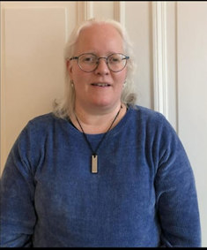 | 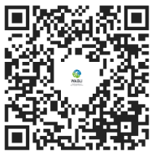
Ronise Barreras
Hello. Hello. Hello, everyone.
As mentioned, My name is Ronise, and I am a Deaf, from the U.S. (United States of America). I'm currently living in the Northwest of the U.S. (United States). You will see English transcript that is also available, so that you can read or use braille to access the information in my presentation as well. I'm a Deaf Woman. I have light colored skin with a salt and pepper colored hair cut short at the neck and I am W earing three quarter length sleeves and a black shirt with a black background. I work as a Deaf(deaf person) interpreter, as well as a Deafblind interpreter, and have done so for the past 20 years. I am a Deaf, and so I experienced that in my own life, but I have been fortunate to have been educated by the Deafblind community as to what they need in interpreters. Over the course of my career, I have been taught by the Deafblind community best practices in this work.
I thank WASLI and the World Federation of the Deafblind for this first opportunity at a workshop. I have presented in the U.S. and in a few places internationally and I am excited about these international partnerships, about how to access language and provide equality by partnership, by equal partnership together as we will define the term co-presence. Presence together, so that visual information is presented tactically or in a way that the Deafblind can access. I do have a PowerPoint. I'm not sure if it's going to show up or not. So, I'd like to explain my journey into the world of Deafblind interpreting. It started back when I was 8 years old. My aunt was a blind hearing individual. I remember noticing that she was able to cook in my home. And that really put, that really gave an impression to me and her ability to do so many things, her independence really left a big impression on me.
And then later when I was 16, I met a Deafblind and was able to communicate with that person as well. And then I moved to Seattle, again in the Northwest of the U.S. (United States), which has a very large Deafblind population. The Seattle Lighthouse for the Blind provided some opportunities for me to be involved in educational pursuits and workshops, which allowed me to begin this work. The Deafblind Service Center was there as well. I volunteered at this service center many times as an SSP, which is the term we use, support service provider. Now that term has become somewhat outdated. Instead, we speak of a person in co-presence, a person who works with a Deafblind person. And In that volunteer work, I did some interpreting as well as some support driving people, taking them grocery shopping, doing a variety of services with Deafblind. And that provided an opportunity for me to internalize some of what I learned. Additionally, the American Association of the Deafblind had a conference that I was privileged to work at again in a volunteer capacity. There was also a Deafblind camp available, again, in my hometown, and I volunteered at that Deafblind camp. At that camp, I was able to meet many Deafblind individuals and recognized the diversity in the community there, as each person was unique. Some used low-vision signing, close vision. Some used tactile signing. Just a variety of ways to communicate.
Additionally, protactile communication, which involved the entire body from the legs to the arms to the back, was also something I was exposed to and that connection was important. That connection, idea of co-presence being together and facilitating information together with the Deafblind really opened my eyes to not only the language of Deafblind but to the world of Deafblind which was quite unique from my world as a Deaf. I recognize the importance of taking everything that I experienced visually and providing that experience in a way that is accessible often tactilely to Deafblind individuals.
I'm sorry, I'm a bit nervous, making sure I'm doing this right. So when we think of how to communicate with Deafblind, one of the important concepts that we need to really emphasize is autonomy. Deafblind people's autonomy in a variety of settings. As a guide, we are not a leader of the Deafblind, but rather we go with them. We provide access to them in a variety of methods. We negotiate linguistic choices in a way that provides the best access to the Deaf, the Deafblind, whether that's tactile or low vision or close range interpreting.
Back in 2007, two Deafblind women established pro-tactile, communication, which was a new communication system involving seven principles. And If you'd like to learn more, there's specific training involved. I'm not going to go through all of the principles of protactile communication, but I think it would be important for you to learn that directly from Deafblind. We now see that this is spreading in Italy and various places in Europe. I know that there's some training available. So if you would like to have that training, it would be great for you to get that training directly from a Deafblind individual.
When I go into a room, with a Deafblind, I may need to visually represent the room. I may need to take what I see visually and create a tactile map, perhaps on my hand or on the hand of the Deafblind to give them the information they want. I give them this information about what's available, a restroom, a friend, a table, whatever they might need so that they can make the decision. They can decide what it is they want to do. So I can explain to them where the water is, and then if they want a drink, they're able to go there. Of course, I can go with them, but they have the autonomy to do that. Perhaps they wish to go on their own, and that's also an option for them if that's their choice.
It's important to provide a good background. Deafblind individuals can struggle if they use residual sight and there is lighting in the background or there's not good contrast of colors. So it's important to have a good dark background to talk with a Deafblind about what's important for their communication needs.
For instance, here on Zoom, there can be some real limitations because there's no opportunity to actually touch any of the people who are talking. So it's important to have a Deafblind interpreter with them to provide many communication options like we're doing here, perhaps with braille, perhaps with tactile sign language, whatever communication option that particular Deafblind wants to use. It's important that they have access to the world. And again, whatever it is that a Deafblind interpreter sees, needs to be placed on the hands to be tactilely communicated so that the Deafblind has access to that same information. It's okay. We don't need to have the PowerPoint. I think we're fine to go on without it. Yeah, I mean, what I have in the chat and what is on the PowerPoint is basically the same information. So I think it's redundant to have the PowerPoint on screen. (not see sign)
Whether it's a Deafblind or a blind person who is hearing, a PowerPoint can provide limited information, although the interpreter can certainly provide access to any of the written information, whether that's in Braille or whether that's in tactile sign language. But regardless, any of the information that's visually depicted has to be perfectly provided in an accessible manner to the Deafblind. So in this case, I think we don't need the actual presentation anyway.
So as we've mentioned, autonomy is a key principle in working with Deafblind. Co-decision making is also important. For instance, if I'm going to eat, and I'm talking with a Deafblind, I don't feed the Deafblind. That would be silly to do, right? They're going to feed themselves, but rather together we make the decisions about how we're going to go about that. And that idea is an example of how we should frame all of our work with Deafblind. We're not leading them, we're not going in front of them, we're not taking them where we want them to go, but rather we're working with them to experience the environment and provide access to the environment, communicating alongside them.
It's possible that close vision is an option that some Deafblind individuals like to use with close vision interpreters. But when their eyes become tired, they may then move to tactile sign language. Or they may choose to use Braille for a time. They may need to rest and have a chance to disconnect from the interpretation. This doesn't mean you're doing a poor job as an interpreter, but it might be in need of the Deafblind. I can't tell you all of the needs a Deafblind might have and you just simply provide them, but rather you need to work with a Deafblind to co-construct the experience.
It's important that as we interpret for the Deafblind, we not label them as a Deafblind who simply can see this percentage or can use vision in this amount. And then assume that's the amount of vision they will have and what they will use for all their communication needs. Instead, we label them as Deafblind and talk with them about what their needs are in this particular situation. And then meet those needs. This empowers them to make decisions about how they will access communication.
For instance, if we want information repeated, rather than we as the interpreter speaking for the Deafblind, we let the Deafblind interrupt. We let the Deafblind ask for repetition of information. This allows the Deafblind to have a more direct experience of their world rather than us making the decisions, making the clarifications for them, asking for the repetitions. We facilitate their own autonomy in asking for that repetition and that clarification.
Next, when we think about touch, touch is essential at all times. When you're with a Deafblind, it's important to understand that as you are with them, you show what you're doing. For instance, even if I look to the side, if I'm beside a Deafblind, they won't know that I'm looking to the side unless I use my hands to show them what it is that I'm looking at. And if they know that I'm looking around and I've used my hand to sign that I'm looking around, then the Deafblind might have questions. What are you looking at? What is it you see? And then you can take any of the visual information that you see and communicate it through tactile communication.
If I'm going to use my phone, I might not simply tell the Deaf, sit there alone, let me use my phone, but rather I might let them keep their hand on my hands while I use my phone so they know what it is that I'm doing. Even if I'm eating or drinking, rather than moving the Deaf away and having, experiencing space alone, you keep the Deaf in that space and you experience that space together So they know what you're doing, whether it's writing or eating or whatever you might be doing. They, through the sensation of touch, can experience what you're doing in your world.
A Deafblind, of course, might have a friend that they're talking with. For me, when I see that happening... I can watch what it is that they're saying, or I might give them privacy by standing behind them. But even when I stand behind them, I will keep my foot on their foot so that they know where I am. Then if they want to give private information to their friend or talk to their friend in private, they can do so, but I haven't left their world. I'm still tactically with them, even though I'm behind them. This provides them the freedom to talk with a friend about whatever they want while recognizing that their guide interpreter is still present. I'm just looking at my list of ideas to make sure I'm covering everything. So what the Deafblind community has taught me so much. As a Deaf interpreter or Deafblind interpreter, I do recognize there are important differences. Interpreting for the Deaf community involves airspace, whereas interpreting for the Deafblind community involves touch space. That importance of being in constant contact, constant physical touch, providing all information tactically is a unique skill that is quite distinct from the skill required to be a Deaf interpreter in a Deaf world that is sighted.
When Deafblind interpreting, it's not simply giving words to the Deafblind. It's giving the words and giving the visual context of those words. It's showing the emotion of the speaker. It's taking everything that you see on the face of the speaker and providing that information, whether it's a smile or a frown or a laugh. All of that information is placed on the hands and delivered tactically. As well as the information from whatever you're interpreting, a particular presentation, as well as the presentation audience that's watching the presentation. So there's many layers of information that have to be provided in interpretation to a Deafblind individual. It's really quite a unique skill to develop. It's quite distinct from what a sign language interpreter does for sighted Deaf, because sighted Deaf have access to the visual world, but not the auditory world, whereas the Deafblind needs access to both the auditory world and the visual world, and they rely on their guide for both.
The Deafblind community helped me learn to take my time, to not rush through things. Taking time allows for connection, which is essential. In Deafblind interpreting, trust is what provides clear access to communication. The Deafblind must trust their interpreter. And then the interpreter must be present, again, as we've mentioned, co-presence. They're in physical contact with the Deafblind so that all experiences are experienced together in contact.
The Deafblind community has taught me the importance of ethics in guiding Deafblind and in working with Deafblind. It's allowing Deafblind access to the entire world around them. For example, when you go to bed at night, you wake up probably with some bright lights around you. But in the Deafblind world, that, that information has to be delivered through the hands. The lights are on, the lights are off, it's dark or it's light. All that information has to be provided tactly.
So this global Deafblind accessibility issue, again, I've talked about my work in the US and my own experiences in the US, but I do recognize that globally there are some diverse experiences, and I have very limited knowledge of those experiences. For instance, in Turkey, I was there, and I was able to have some experiences, but I wasn't able to fully integrate all of those. I would say Turkey and Republic of Korea are the only two places where I've had some in-depth experiences. So I can't speak for the entire world, and I don't wish to say that any particular way of being is right or wrong, but rather I want to emphasize the individuality of each place.
It's important that we develop the CISI, the Certificate of International Sign Interpreting, that is beginning to be developed. I'm excited about that.
For BIPOC people, additionally, which is Black, Indigenous, and people of color, we think about that in North America, but also we can think about the global South as well, whether that's Asia, Africa, Indigenous people, South American people, people in India. It's important that we develop, we work with all of the developing world, we can sometimes become quite Eurocentric and not recognize the need for the entire world to have access to this information and to these best practices.
Again, pro-tactile communication is available, training is available if you seek it out. It is possible to be in touch with people to get that training. When we talk about ethics, again, I'm familiar with ethics as they're generally presented in the US. There may be some differences in other cultures and other places. And so we need to be able to accommodate those cultural differences. As we figure out what is the most ethical practice in a given situation. This requires great flexibility with ourselves, with our ethics, with our cognitive approach, with our communication approach, with everything that we do.
It's important that we network with other hearing interpreters, other Deaf interpreters, Deafblind interpreters, international sign interpreters, that we grow our network, because that is going to grow goodwill among all of us as the community. It's important that we maintain humility. I could easily say, well, I've done this for 20 years. I know everything, but I don't. Instead, I'm constantly learning from the Deafblind community and from other communities that I work in, and I'm open to what I don't know and what I need to learn.
When we talk about global issues, we might think about the UN. We might think about the Convention on the Rights of Persons with Disabilities. We might specifically think about Article 9, about access to information, Article 21, about the right to communicate, whether that's tactile sign language or Braille sign language, Article 19, the right to live in the community with the support that is required to, which again brings in the right to Deafblind guides and interpreters. Article 24, the right to education and to have access to education, which includes training, includes credentialing. And then CRPD 30, The right to participate in cultural events, sports, recreation, swimming, tennis, Deaflympics, Deafblind can be involved in those things. So it's important that we recognize and internalize this global perspective on the rights of all people, including Deafblind.
Okay, I'm almost finished. There's just four things that I, that on behalf of the Deafblind community, I would like to ask. So I'm going to put those in the chat here. Sar Morrison says this, inclusion means you can come in You're not on the outside, but you can be on the inside. That's the idea of inclusion. On the other hand, equity says, what tools and accommodations do you need to succeed once you are here? So of course we need inclusion, but we need to go further than that to equity. This will allow Deafblind to be successful. For instance, that principle has been incorporated in the Deafblind Center, and Sara Morrison is the person who we thank for that.
Additionally, Keith Clark says touch within three seconds of meeting, which means when you meet a Deafblind, immediately touching the person so they are aware that you are there, not leaving them without touch, but remaining in touch, whether that's at a conference, whether that's with friends, at a workshop, wherever that may be, staying there in co-presence, in physical contact. Next from the person A.J. Granda, we see... “ Deafblind woman who, this is the Deafblind woman, one of the two people who were involved in establishing protactile communication and the seven principles, A.J. Granda was. So this is the quote from A.J. Granda: “Protactile and co-presence refuses to accept a hierarchical privileged base model of help and instead insist on mutual presence and reciprocity.
And last, this is me. It's not I help you. It's we do this together. This term that I've used, co-together, it's not actually an English term, but it's a term that I like to use to really emphasize. We use the term co- with many things and many words. So I've used that prefix co- with together to emphasize. It's not one over the other, it's not one in front of the other, but it's people together, a Deafblind and the Deafblind guide together in all ways.
At the same time, physically in the presence, providing all of the information, providing the sensation of the other person tactilely, feeling their breath, feeling their life together.
That is our goal. All right, I believe I'm done. I want to thank you all for your time, especially Lydia. Thank you. Thank WASLI. Thank the World Federation of the Deafblind. I want to thank you all for this opportunity and thank you for your attention.
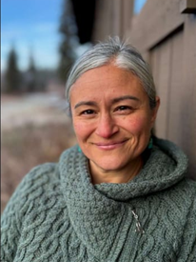 | 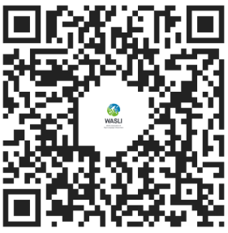

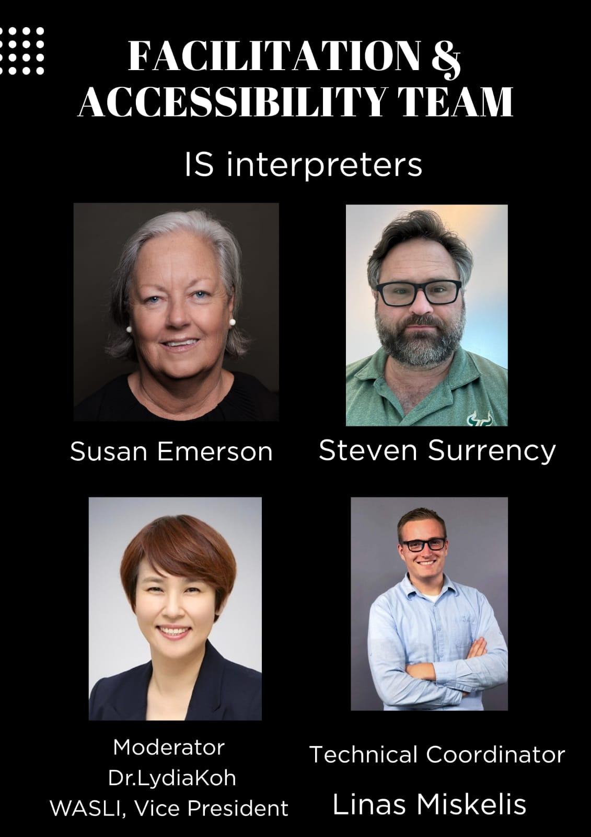
Image description: This image is a presentation slide titled “Facilitation & Accessibility Team – IS Interpreters.”
The slide has a black background with a clean, professional layout. It introduces four team members with their photos, names, and roles:
Susan Emerson – Shown in a formal portrait with short gray hair.
Steven Surrency – Shown wearing glasses and a green shirt, with a beard.
Dr. Lydia Koh – Identified as the Moderator and WASLI Vice President, shown smiling in a professional portrait.
Linas Miskelis – Identified as the Technical Coordinator, shown standing with arms crossed in a light blue shirt.
Each person is displayed in a grid format with their name written below their photo. The slide clearly highlights the facilitation and accessibility team responsible for supporting the webinar.

Publication Date: 30th March. 2026
Published by: WASLI (World Association of Sign Language Interpreters)
WFDB (World Federation of the Deafblind)

We would like to sincerely thank the following contributors who helped prepare the WASLI–WFDB webinar script.

WASLI–WFDB Webinar Script Team:
Ruth Taiwo (Nigeria)
Douglas Izuchukwu (Nigeria)
Sherrette Gárate-Estes (USA)
Nguyen Ha My (Mee) (Vietnam)
Lamjav Soyolmaa (Mongolia)
Dong Han Kim (South Korea)

Prepared under the coordination of:
Kounghee Koh (Lydia)
Vice President, WASLI

