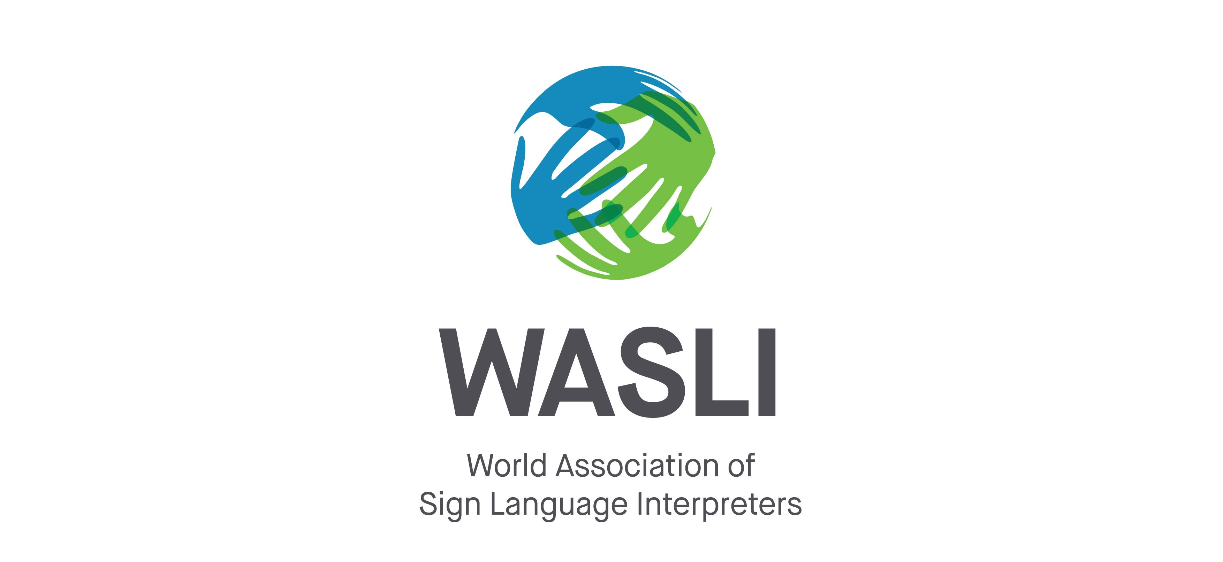
WASLI is committed to the development of the profession of sign language interpreting worldwide

APPLICATION FOR RESEARCH SUPPORT

One of the objectives of WASLI is to share information and be a reference on interpreting issues. In order to achieve this objective, WASLI seeks to encourage research by providing researchers with the opportunity to collect data through the WASLI membership and networks, e.g., by distributing surveys or requests for participation in research studies. Before providing this opportunity, however, the WASLI Executive needs to ensure that any research conducted with WASLI endorsement will contribute to the development of theoretical and/or practical insight into the signed languages profession. Furthermore, that this research will be carried out ethically and will not have any detrimental effect on its members. Therefore we ask all researchers to submit an application to the WASLI Research Review Committee for approval. Once a project is approved, WASLI will provide support for the project wherever possible.

WASLI also recognises the primacy of National Associations of the Deaf (NADs) to chart the political, cultural and educational development of signed languages in their country including the dissemination of sign language dictionaries and teaching materials. As a result, WASLI requests that researchers seek the support of their country’s NAD for their research project.

Since the goals of the research needs to contribute to the development of the of theoretical and/or practical insight into the signed languages profession, WASLI asks that researchers seek the support of their country’s National Association of Sign Language Interpreters organization.

Please note: WASLI does not review research projects in order to provide funding. The goal is to facilitate researchers’ ability to contact a worldwide network of sign language interpreters.

APPLICATIONS MUST BE TYPED OR WORD PROCESSED AND SENT TO THE CHAIR OF THE WASLI RESEARCH REVIEW COMMITTEE

SECTION 1: PROJECT SUMMARY AND ADMINISTRATION DETAILS

Full Project Title:
Project Start Date:
Project End Date:
Name of Principal Researcher and Contact Person:
Position:
Organisation:
Full Mailing Address:
Telephone Numbers
Work:
Home:
Mobile:
Fax:
Email Address:

Before completing the following sections, please ensure you have reviewed the Reviewer’s Checklist, which tells you what criteria will be used by the Review Team to assess your application.

1.1 Please provide a brief description of the research (150 words maximum).

1.2 Please provide a brief description of the research goals (150 words maximum).

1.3 Please explain your research methodology and design (150 words maximum).

1.4 Please explain what type of help you are seeking from WASLI.

1.5 Include a curriculum vita listing of your research background.

SECTION 2: ETHICS

2.1 Has this research project received approval from a university or institutional Ethics Review Committee?

YES NO

2.2 If yes, please provide the details of the university/institution and date of approval. Attach a copy of the Ethics Approval and Application as an Appendix to this application.

University/Institution Name: | Date of Approval:

2.3 If no, please provide explain how you will comply with the standard ethical practices involving human research. (Please see the reviewer assessment on page 6.)

2.4 Please attach a copy of the instruments or samples of items to be used, including tests, interview guides, and observational schedules as an Appendix to this application.

SECTION 3: SUPPORT FROM A NATIONAL ASSOCIATION OF THE DEAF

3.1 Do you have a letter of support from your National Association of the Deaf?

YES NO

3.2 If yes, please attach the letter as an Appendix to this application.

3.3 If no, please explain why not.

SECTION 4: SUPPORT FROM A NATIONAL ASSOCIATION OF SIGN LANGUAGE INTERPRETERS

3.1 Do you have a letter of support from your National Association of Sign Language Interpreters?

YES NO

3.2 If yes, please attach the letter as an Appendix to this application.

3.3 If no, please explain why not.

PLEASE SEND THIS RESEARCH APPROVAL APPLICATION TO:

The WASLI secretary
Email: secretary.wasli@gmail.com

The WASLI Research Review Committee will consider your application based on this application and using the Reviewer Assessment below. You will receive a response within 6 weeks of receipt of your application. Responses may include conditional approval subject to adaptations or more information as required.

Principal Researcher:
Project Title:

REVEIWER ASSESSMENT | Yes | No | N/A
- Does the researcher provide a clear statement of what is to be done?
- Is there a clear explanation of the involvement of human participants?
- Is it clear that the study will not be harmful or threatening to the participants or others?
- Has the matter of informed written consent of participants been attended to?
- If there is any circumstance that could compromise the voluntary consent of participants (e.g. Incentives, captive populations, second relationship), has this been satisfactorily accounted for?
- Is the process of recruiting participants and obtaining permission(s) clearly described?
- Are the data collection procedures clearly specified?
- Have copies of instruments or samples of items to be used, including tests, interview guides, and observational schedules been provided?
- Have information letters, consent forms, and other attachments as appropriate been provided?
- Has the right to:
  - not participate been provided?
  - opt out without penalty, harm or loss of promised benefit, and the time frame for opting-out (e.g., up to completion of data collection activities, two months after the completion of data collection activities).
- In the event of a participant opting out of the study have the opportunities for withdrawal of data been clearly specified?
- If underage, legally incompetent, or other “captive” subject are used, is there provision for the right to opt out for:
  - the subjects and
  - their parents/guardians?
- Has provision been made for explaining the nature, length and purpose of the research to the participants and/or guardians?

- Are the procedures for providing privacy, anonymity and confidentiality acceptable?
- If there are limited and/or temporary exceptions to the general requirements for full disclosure of information, is there clear provision for debriefing of participants?
- If inducements or promises are offered for participants, are they of such a nature that they do not compromise freedom of consent?
- Are all aspects of the study that need special ethical consideration specified and acceptable?

NOTES:

